Game Design Document

Fill up the Following document

1. Write the title of your project.

Aquaria.

1. What is the goal of the game?

The goal of the game is to save the water and destroy all the human space craft before they enter the planet.

1. Write a brief story of your game?

In the game there is a planet named **Aquaria** which is made only of water and only Marine life is possible here. This planet is a home for many species of water animals specially **mermaids**. Aquaria has a special feature that the water of this planet acts like a medicine and can cure any disease. Now, when humans come to know this they planned to attack Aquaria by using their high quality spacecrafts. Now, mermaids planned to fight with humans and elected two mermaids to fight with humans. The mermaids have only 4 type of guns to shoot.

1. Which are the playing characters of this game?

* Playing characters are the ones which respond to the user based on the input from the user
* Cars, monkeys, dinos, wizards etc, are the playing characters in the game.

|  |  |  |
| --- | --- | --- |
| Number | Character Name | What can this character do? |
| 1 | Mermaid 1 (with the help of different type of guns) | It can destroy space  Crafts coming from top and right direction (arrow keys used). |
| 2 | Mermaid 2 ( with the help of different type of guns) | It can destroy space  Crafts coming from bottom and left direction (arrow keys used). |
| 3 | Gun1 | Can shoot 1 bullet at a time. |
| 4 | Gun2 | Can shoot 2 bullets at a time. |
| 5 | Gun3 | Can shoot 3 bullets at a time. |
| 6 | Gun4 | Can shoot 4 bullets at a time. |
| 7 |  |  |
| 8 |  |  |

1. Which are the Non Playing Characters of this game?

* Non Playing characters are the ones which don't have an action or a behaviour when the user interacts with the game.
* Hurdles, stones, bananas, coins, etc are non playing characters in the game.

|  |  |  |
| --- | --- | --- |
| Number | Character Name | What can this character do? |
| 1 | Space crafts | They come randomly from top, bottom, left and right and attack the mermaids. |
| 2 |  |  |
| 3 |  |  |
| 4 |  |  |
| 5 |  |  |
| 6 |  |  |
| 7 |  |  |
| 8 |  |  |

Draw your imagination of this game. What does this game look like?

* Draw the game either on your computer or on paper,
* Add images of scenes of the game to show each of the playing and non-playing characters at least once.

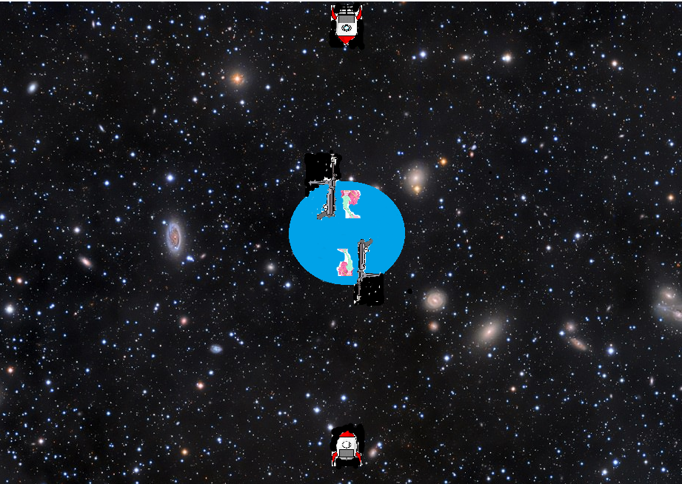

How do you plan to make your game engaging?

I can add scoring system to the game that whenever a space craft is destroyed the score will increment by 1. The game will over when we will lose all the lives, i.e, 3. I can introduce the concept of game adaptation in the game by increasing the speed of human attack as the time increases. I can add sound effects to the game respectively. I can add buttons having guns where we can choose which gun we have to take in which every gun will load in a particular time.